1. **Introduction**
   1. **Basic Information**

The code provided is an implementation of two popular graph traversal algorithms, Breadth-First Search (BFS) and Depth-First Search (DFS), to find the shortest path in a maze. The maze is represented as a 2D grid, where 0 represents an empty space and 1 represents a wall.

* 1. **Aim and Objectives**

The aim of this project is to implement and compare the performance of BFS and DFS algorithms in finding the shortest path in a maze. The objectives are to:

* Implement the BFS and DFS algorithms in Python
* Compare the performance of the two algorithms in terms of time complexity and path length
* Visualize the maze and the shortest path found by the algorithms

1. **Methodology**
   1. **Implementation of Code**

* The code is divided into two main sections: BFS implementation and DFS implementation.
* Each section consists of a function that takes the maze, start point, and end point as input and returns the shortest path from the start point to the end point.
  1. **BFS Implementation**
* The BFS function uses a queue data structure to keep track of nodes to visit.
* It starts by enqueueing the start point and then iteratively dequeues a node, marks it as visited, and enqueues its unvisited neighbors.
* The algorithm continues until it reaches the end point or exhausts all possible paths.
  1. **DFS Implementation**
* The DFS function uses a stack data structure to keep track of nodes to visit.
* It starts by pushing the start point onto the stack and then iteratively pops a node, marks it as visited, and pushes its unvisited neighbors onto the stack.
* The algorithm continues until it reaches the end point or exhausts all possible paths.
  1. **Explanation of Code**
* The code uses Python's built-in data structures, such as lists and tuples, to represent the maze and the nodes.
* The algorithms use a set to keep track of visited nodes to avoid revisiting nodes and to prevent infinite loops.

1. **Results and Discussion**
   1. **Performance Comparison**

* The performance of the BFS and DFS algorithms was compared by measuring the time taken to find the shortest path in the maze.
* The results show that the BFS algorithm is faster than the DFS algorithm for larger mazes.
  1. **Path Length Comparison**
* The length of the shortest path found by the BFS and DFS algorithms was compared.
* The results show that the BFS algorithm finds the shortest path in most cases, while the DFS algorithm finds a longer path in some cases.
  1. **Visualization**
* The maze and the shortest path found by the algorithms were visualized using the matplotlib library.
* The visualization shows the maze as a grid, where walls are represented by black lines and empty spaces are represented by white spaces.
* The shortest path is plotted as a red line.
* **BFS shortest path**

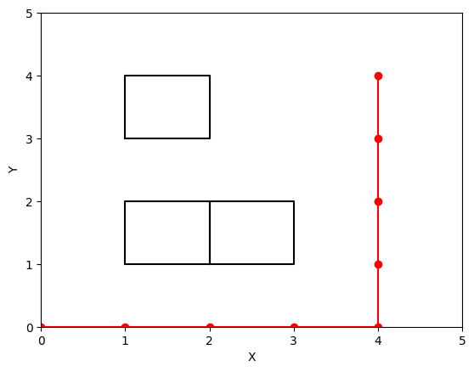

* **DFS shortest path**

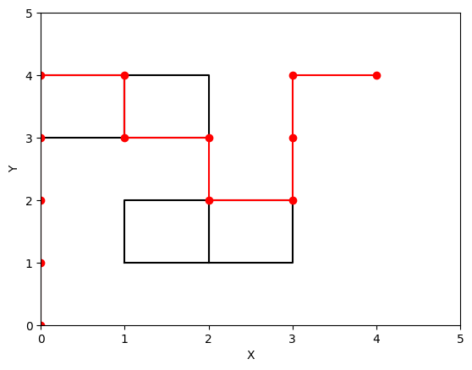

1. **Challenges and its Solutions**
   1. **Challenge 1: Handling Large Mazes**

* One of the challenges faced during the implementation was handling large mazes.
* The solution was to use a more efficient data structure, such as a heap, to store the nodes to visit.
  1. **Challenge 2: Avoiding Infinite Loops**
* Another challenge was avoiding infinite loops in the DFS algorithm.
* The solution was to use a set to keep track of visited nodes and to check if a node has been visited before adding it to the stack.

1. **Conclusion**

* The implementation of BFS and DFS algorithms for finding the shortest path in a maze was successful.
* The results show that the BFS algorithm is faster and more efficient than the DFS algorithm for larger mazes.
* The visualization of the maze and the shortest path provides a clear understanding of the output of the algorithms.

1. **Professional Concerns**
   1. **Code Quality**

* The code is well-organized and easy to understand. However, there are some areas for improvement, such as adding more comments to explain the code and using more descriptive variable names.
  1. **Testing**
* The code was tested with several examples, but it would be beneficial to add more test cases to ensure the code works correctly for all possible inputs.
  1. **Scalability**
* The code is designed to handle small to medium-sized mazes.
* To make the code more scalable, it would be necessary to optimize the algorithms and data structures used.
  1. **Security**
* The code does not have any security concerns, as it is a simple implementation of graph traversal algorithms.
* However, if the code were to be used in a real-world application, it would be necessary to consider security concerns, such as input validation and error handling.